**Apple iPhone Administration Guidexxx**

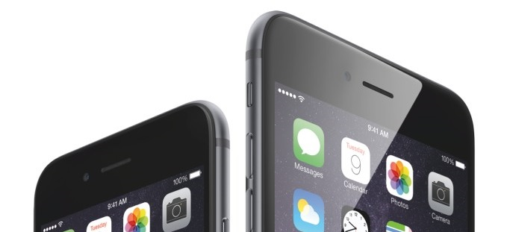

|  |  |
| --- | --- |
| Date: | 03.12.2015 |
| Version: | V 1.2 |
| Responsible for content: | GIM |
| Scope: | WILO SE |
|  |  |
| Released on: | 03.11.2015 |
| Released by: | Group Information Management |

# Contents

Contents 1

1 How to add a User on BES12 2

2 How to add/delete a Device on BES12 3

2.1. Adding a Device on BES12 3

2.1.1. DEP Apple iPhones 5

2.1.2. Non-DEP Apple iPhones 9

2.2 Deleting a Device on BES12 12

# 1 How to add a User on BES12

For adding (onboarding) a user to the BES12 Environment, the user needs to be in a specific Active Directory Group. The Active Directory Group is called

**BES-DEFAULTUSER** with the local prefix, for example

**FR-CH-BES-DEFAULTUSER.**

The active directory groups are located within every local tree of the Active Directory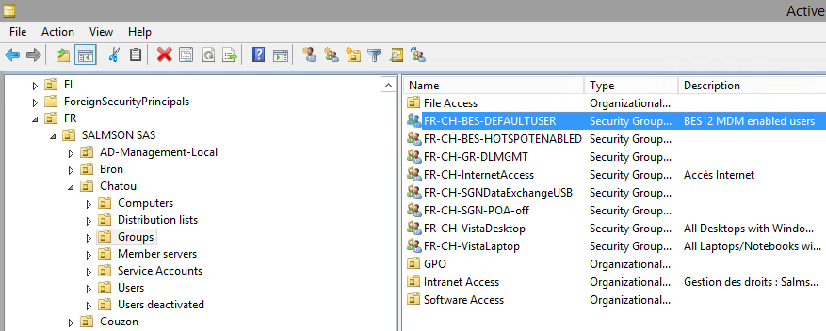. Those groups are located within the structure at the same position within the root of the organizational unit ‘Groups’ in the local tree of the regarded location. Adding users to these inherited groups enable the administration within the BES12 environment.

The replication time between BES12 and AD is 30min, meaning at the latest of 30min after adding the user will appear within the BES console (Every full hour and half past an hour).

# 2 How to add/delete a Device on BES12

When activating a new Device for a specific user, use the BES12 Admin Console under: <https://de-do-bes01.ads.wilo.de/admin/>  
Use your winlogon credentials and the domain “**wilo**” to log in.

## 2.1. Adding a Device on BES12

1. Search for the User you want to add a device to.

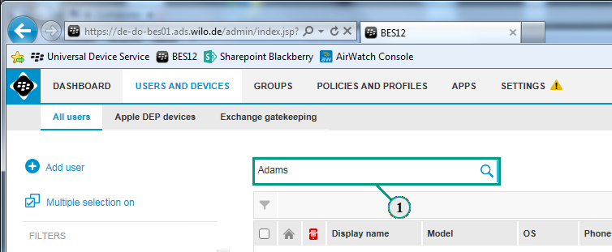

1. Click on the found user.

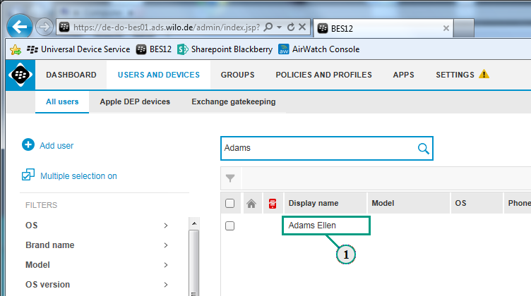

1. Then click on “Set Activation Password”.

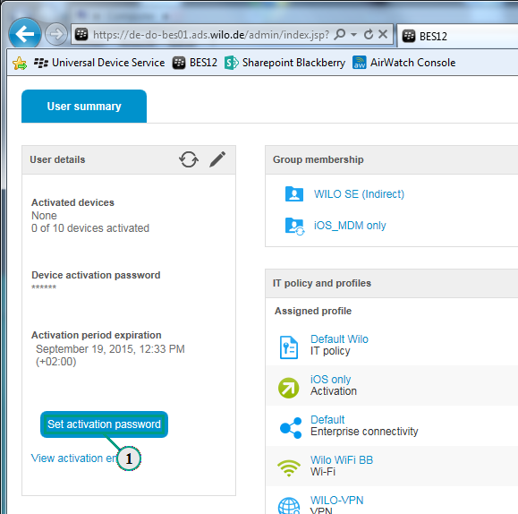

1. After this you can choose whether you want to add a specific password or let BES12 generate one. Click on save when done.

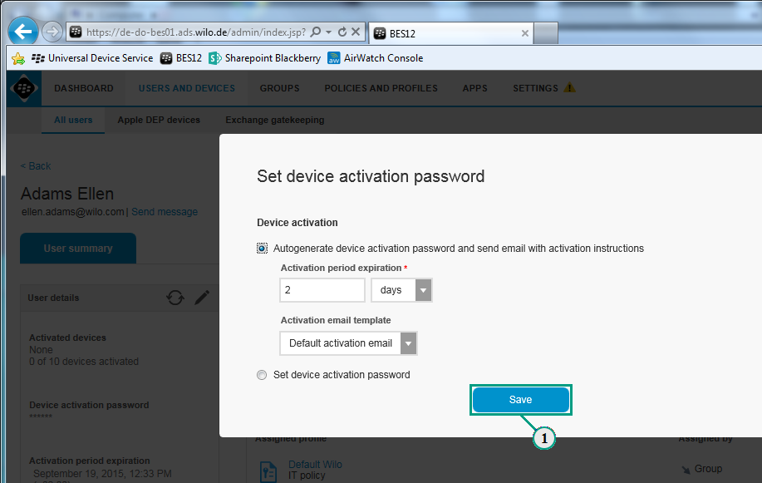

1. After this the user will get two E-mails. The first one contains the password needed to connect to BES12 with your device. The second one contains the used work e-mail address and the activation user name. There is also a short video-tutorial for the user how to download the needed BES12 App from the Apple App Store.

### 2.1.1. DEP Apple iPhones

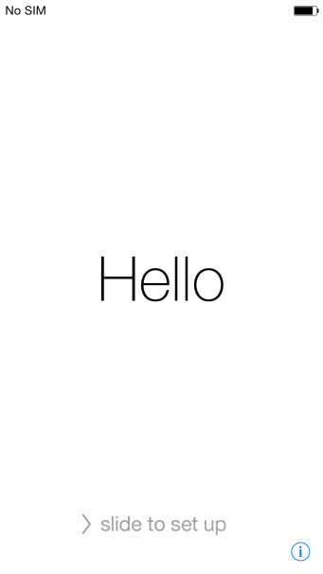If your device is tagged as an Apple DEP (Device Enrollment Program) device, the configuration on the device itself is quickly done.

1. This is the start-screen on a freshly reset or purchased Apple iPhone.
2. 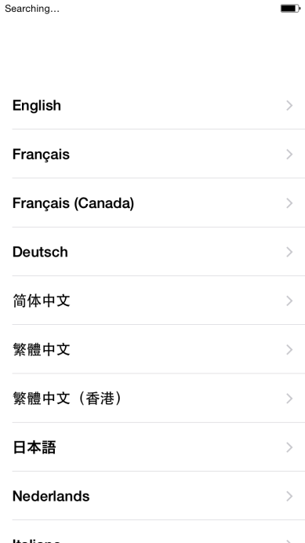After the start-screen you have to choose your preferred language and the country setting up the iPhone for.

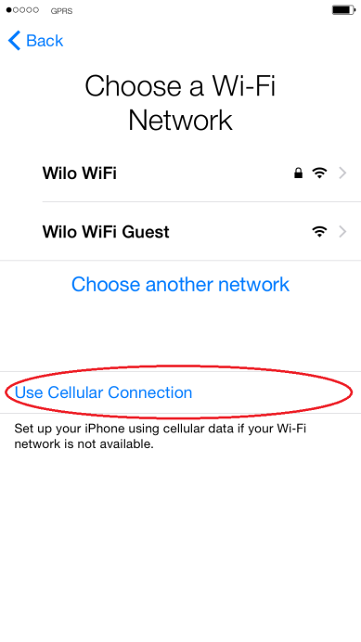

1. Unlock your SIM card with your PIN and wait for the device getting a connection to the cellular network. This may take a few minutes until the device finds mobile service. As soon as the field gets available tap on “Use Cellular Connection”. If you don’t have a sim card to use, you need to connect to an accessible WLAN to continue.

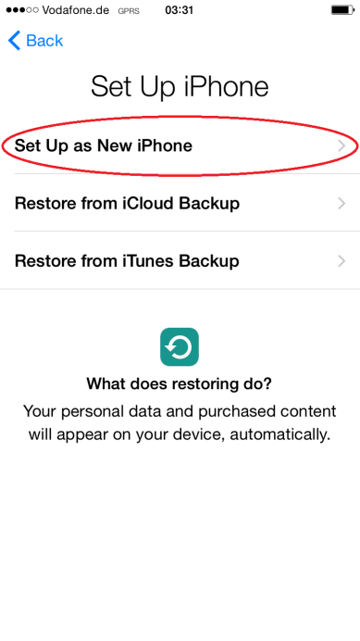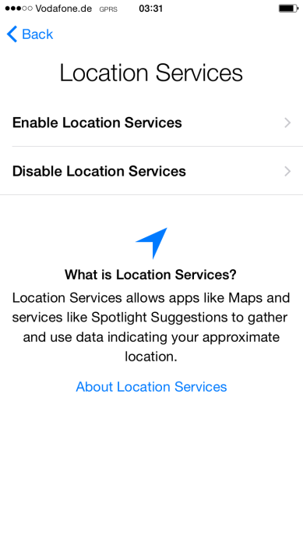

1. Choose if you want to enable or disable the location services yourself and set up the iPhone as a new iPhone after getting connected to the cellular network.
2. 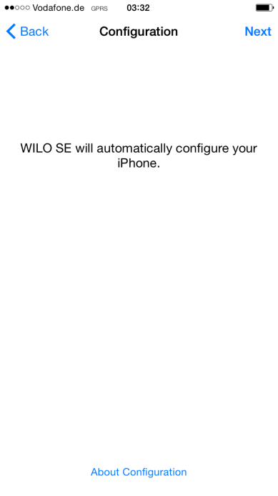You will see the Apple DEP Process starting. The IMEI (Serial Number of the Device) is linked to BES12 trough the DEP and starts deploying all configured profiles on the Apple iPhone.
3. Now you need to hand-out the device to the user. 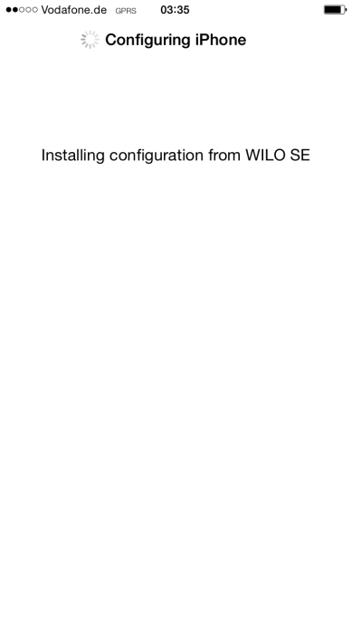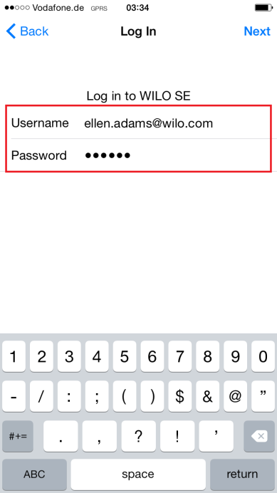Enter the activation username and the activation password given in the two E-Mails by BES12 to the user. After entering the credentials BES12 is installing the profiles.
4. 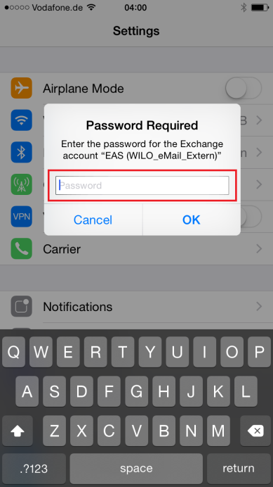The user now has to enter the Exchange Active Sync password (Same as windows logon password) to the device for syncing E-Mails, Contacts and Calendar. When the Pop-up doesn’t come immediately after setting up the device, start the “Settings” App and the Pop-up shows up.   
     
     
     
     
   If it still doesn’t show up or entered incorrectly, configure the E-Mail access like this:
   * 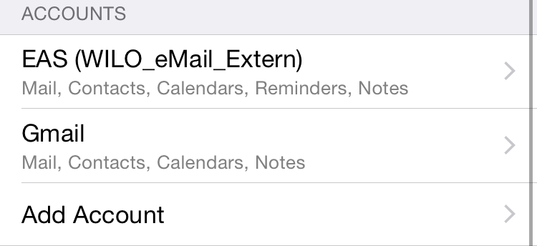Navigate to **Settings**
   * Navigate to **Mail, Contacts, Calender**
   * Tap on **EAS (WILO_eMail_Extern)**
   * 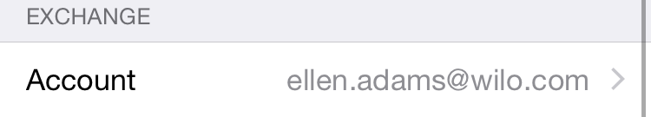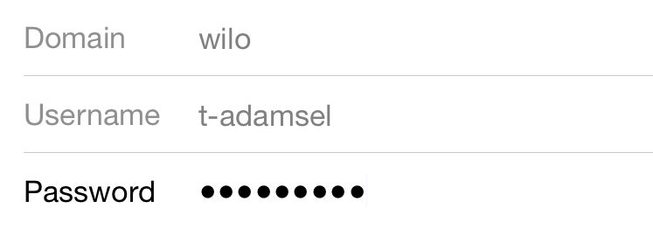Tap on your Account (your corporate E-Mail address) and enter the password (Windows logon password)

### 2.1.2. Non-DEP Apple iPhones

If the Apple iPhone you want to add isn’t a DEP Device, there is a minor change in adding it. Step **1-4** from **“2.1.1. DEP Apple iPhones”** is the same for DEP and non-DEP iPhones, so we start at point 5.

1. 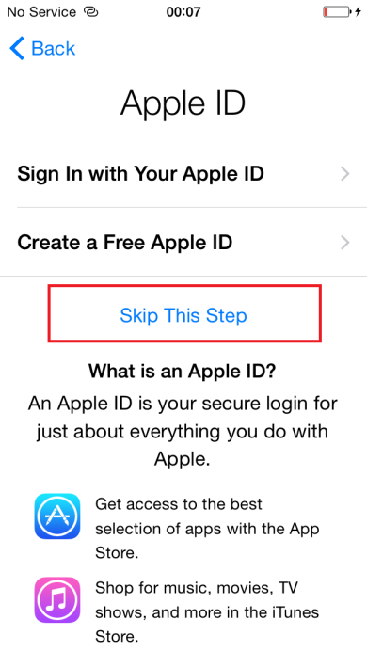After doing steps 1-4 you will be asked to enter an AppleID. The user needs to type in his own private ID so he can download and update the BES12 App. Tap “Skip this step”.
2. 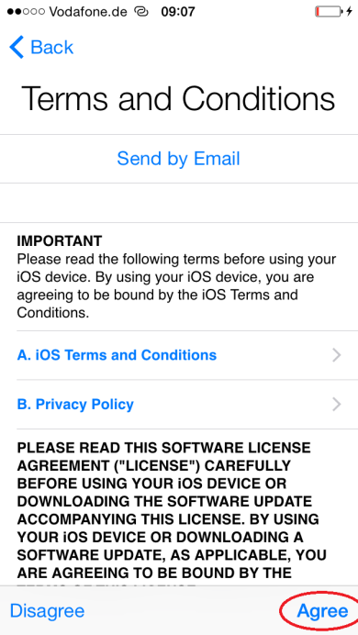Read and agree the Apple terms and conditions.
3. 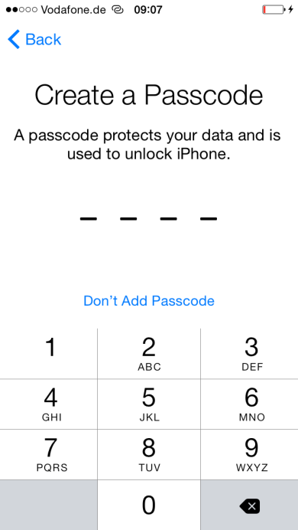Enter a provisionally Passcode or skip this step. The WILO profile requires a specific passcode. The user will be forced to create a passcode by Popup after installing the BES12 App and connecting it successfully to the enterprise.

1. Now you have to hand-out the device to the user. The User needs his own, private AppleID for downloading the necessary BES12 App from the App-Store. For more information about AppleID the user can look up in Chapter 2 of the official iPhone user guide. How to obtain and connect the BES12 App is shown in a short video in the second E-mail from BES12 given to the user which contains the activation username.   
   (Link: <http://docs.BlackBerry.com/activate-your-device-on-BES12.html>)  
   As soon as the user wants to download the BES12 App (BES12 Tutorial Step 4), he will be asked for an AppleID. Now he needs to enter the private AppleID.
2. After the BES12 Client is installed and connected like shown in the BES12 Tutorial, the user has to enter the Exchange Active Sync password (Same as windows logon password) to the device for syncing coorporate E-Mails, Contacts and Calendar. When the Pop-up doesn’t come immediately after setting up the device, start the “Settings” App and the Pop-up shows up.

If it still doesn’t show up or entered incorrectly, configure the E-Mail access like this:

* + Navigate to **Settings**
  + Navigate to **Mail, Contacts, Calender**
  + Tap on **EAS (WILO_eMail_Extern)**
  + Tap on your Account (your corporate E-Mail address) and enter the password (Windows logon password)

## 2.2 Deleting a Device on BES12

Deleting a device is the same procedure on DEP and non-DEP Devices.  
On the BES12 admin console:

1. 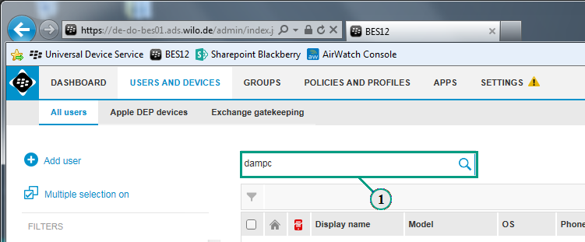Search for the user you want to delete a device from.
2. 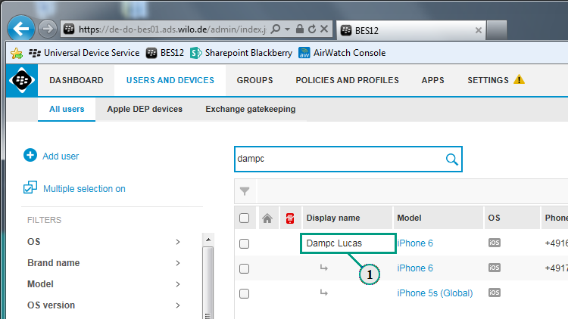Click on the found user.

1. Now you will see all activated devices for the user. Click on the device you want to delete.  
     
   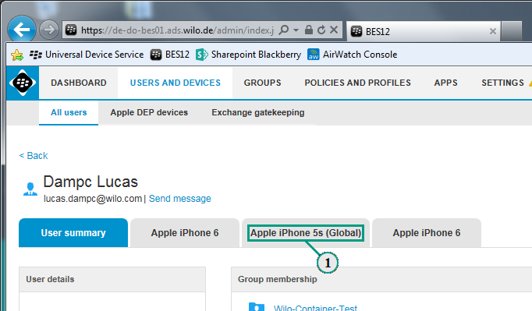
2. You will see all remote options for this device. Also you will have two different options for deleting a device**. “Delete only work data”** will delete all WILO profiles and installed apps. Any other data than WILO profiles and installed apps will still be available. **“Delete all device data”** will immediately set the device to factory setting, deleting any content on the phone. DEP devices still will be branded to WILO, making it impossible to use them for 100% private usage.

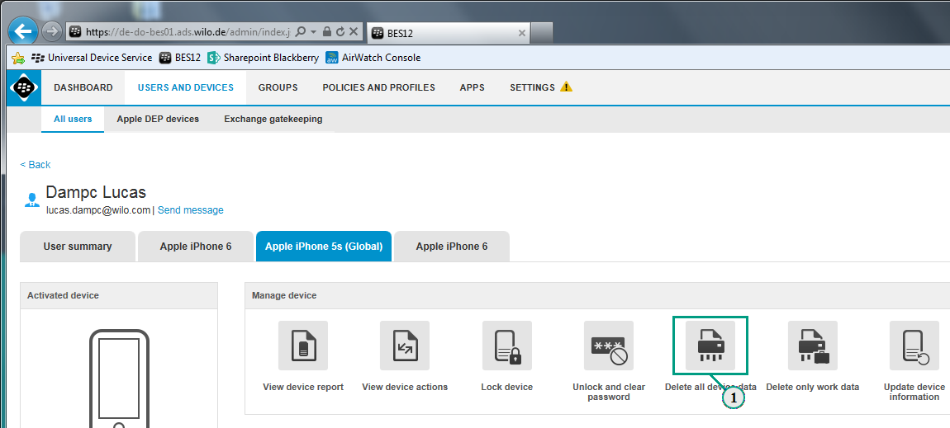

1. Proceed with “Delete all device data”/”Delete all work data”

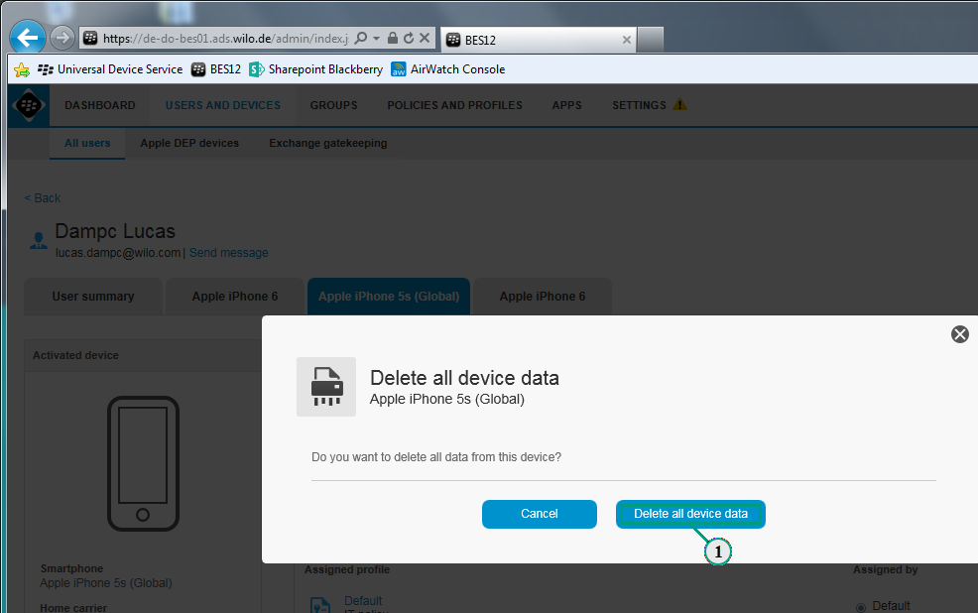

1. Now you will see the device is no longer in the overview and has been deleted.  
     
   